# Notes on FHIR on claims/clinical Access

HL7 Financial Module:

<https://hl7.org/fhir/financial-module.html>

Cigna Coverage and claims:

<https://www.cigna.com/health-care-providers/coverage-and-claims/>

Youtube Video on FHIR Claims/clinical data access :

[Dharmesh Patel, Mike Arce - Claims on FHIR | DevDays June 2021 Virtual](https://www.youtube.com/watch?v=1V1_wOv44hs&t=208s)

[Ricky Sahu - Clinical and Claims Data Transformation utilizing FHIR Bulk Data | DevDays June 2021](https://www.youtube.com/watch?v=jX8GsFaFS3M&t=39s)

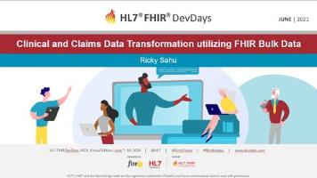

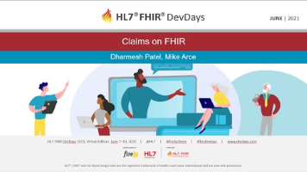

Terms:

**Payers** in the health care industry are organizations — such as health plan providers, Medicare, and Medicaid — that set service rates, collect payments, process claims, and pay provider claims

A **health insurance provider** network is a group of healthcare providers that have contracted with a health insurance plan (via an HMO, EPO, PPO, or POS plan) to provide care at a discount and accept the discounted price as payment in full

**Healthcare providers** include hospitals, doctors, nursing staff, clinics, nursing homes, medical practitioners, nutritionists and dieticians, and many more.

**Understanding the claims flow in healthcare sector:**

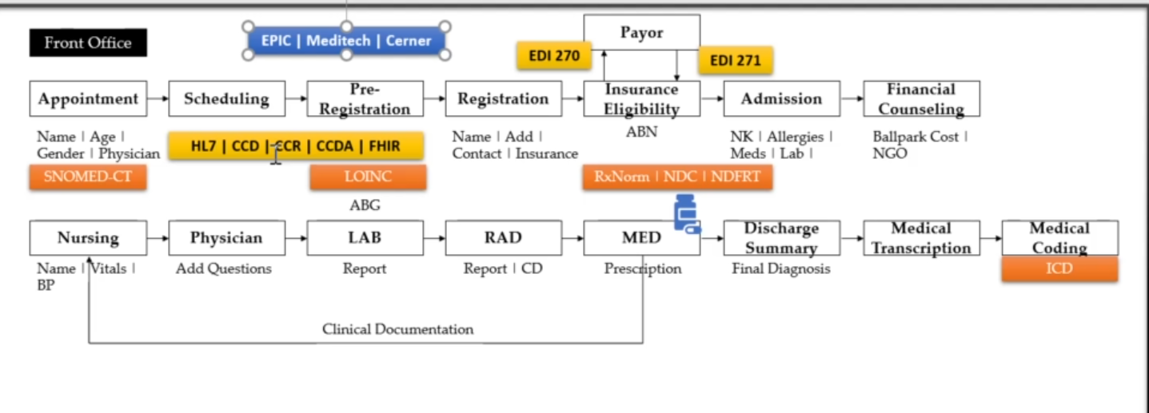

 Orange-> codes

Yellow-> Data Transmission

Blue-> Vendor(mostly specialist in a portion: eg., 1. Appointment- > Epic 2. Registration-> cerner 3.Financial Concelling-> Meditech)

